**UNIVERSITY COLLEGE OF ENGINEERING**

**TINDIVANAM**

(A Constituent College of Anna University)



# ELECTRONICS AND COMMUNICATION ENGINEERING

**NAAN MUDHALVAN DIGITAL MARKETING PROJECT**

**TEAM MEMBERS**

# TEAM LEADER: Kavinasri G (au422420106016)

**NM id: DDF7B4D40A746DEB72845123444EFB9F**

**TEAM MEMBER 1: Mohamed ameenul aslam H (au422420106019)**

**NM Id: E85DF6C27746FA4BAA94436782635262**

**TEAM MEMBER 2: Vijayasurya R(au422420106033)**

**NM ID: 4C12E9102FD9D30AD0647C01A886FA48**

**TEAM MEMBER 3: Viswanath T (au422420106034)**

**NM ID: B0A93D4C81497F0BE1C4A4E7A4F20806**

**TEAM MEMBER 4: Mahaveer s (au422420106301)**

**NM ID: E16EC6B42F12730A66E48B511CCF9C95**

**TEAM MEMBER 5: Annamalai K (au422420106001)**

**NM ID: 43FDD9AF6717048B47C494A21D587987**

### **PROJECT TITLE:** How To Create A Brand Promo Video Using Canva

### **STEP 1:** Create Design

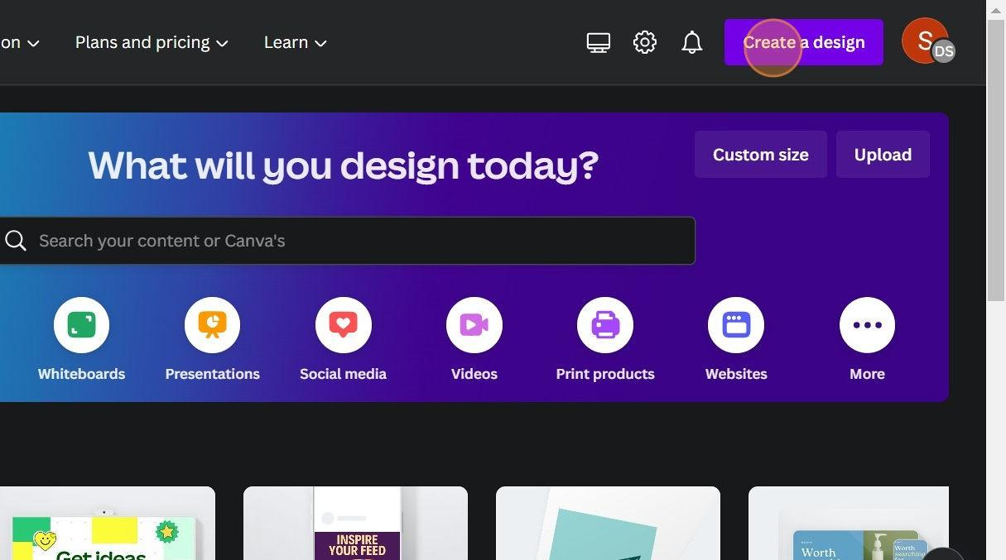**name.**

### **STEP 2:** Choose Design Layout

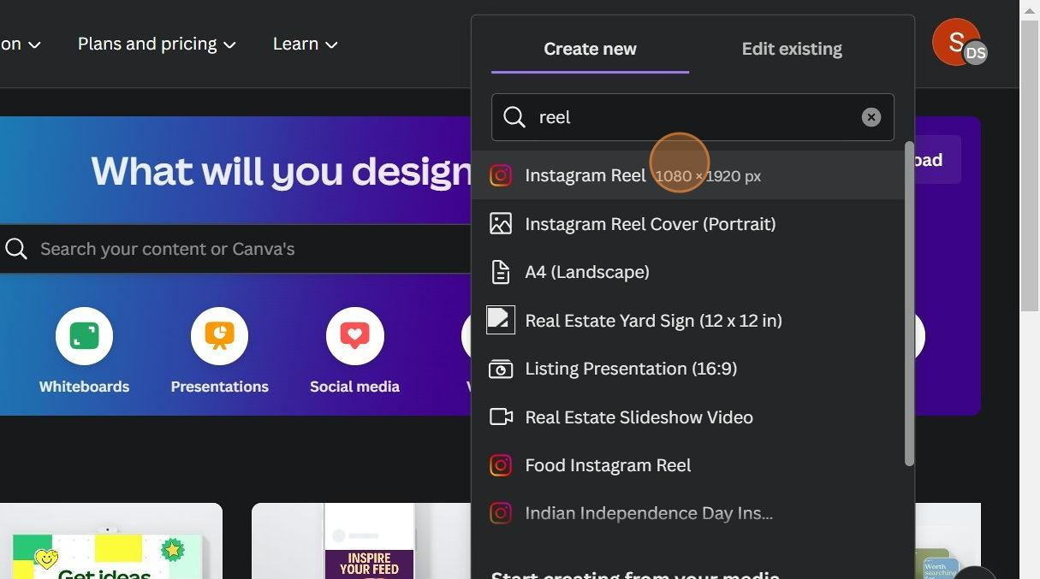

### **STEP3:** Templates

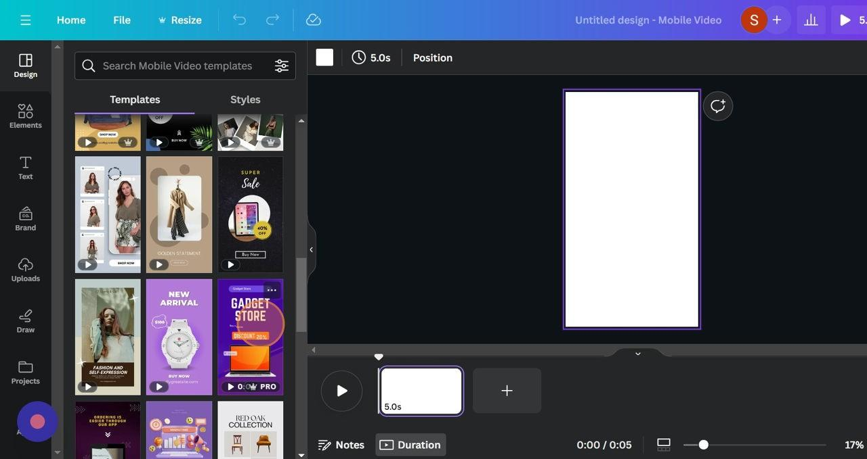

### **STEP4:** Add page

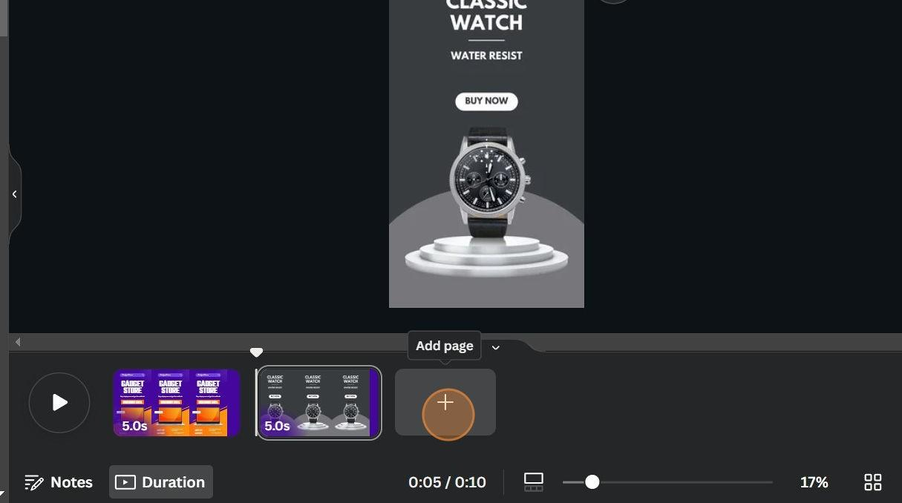

**STEP5:** Edit Text Contents

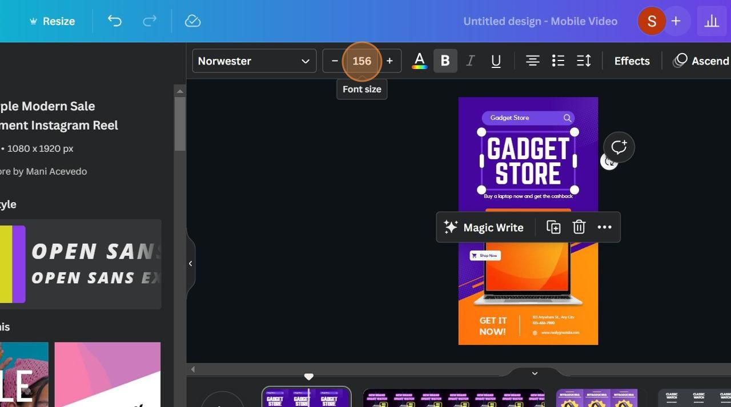

### **STEP6:** Upload Images, Logo

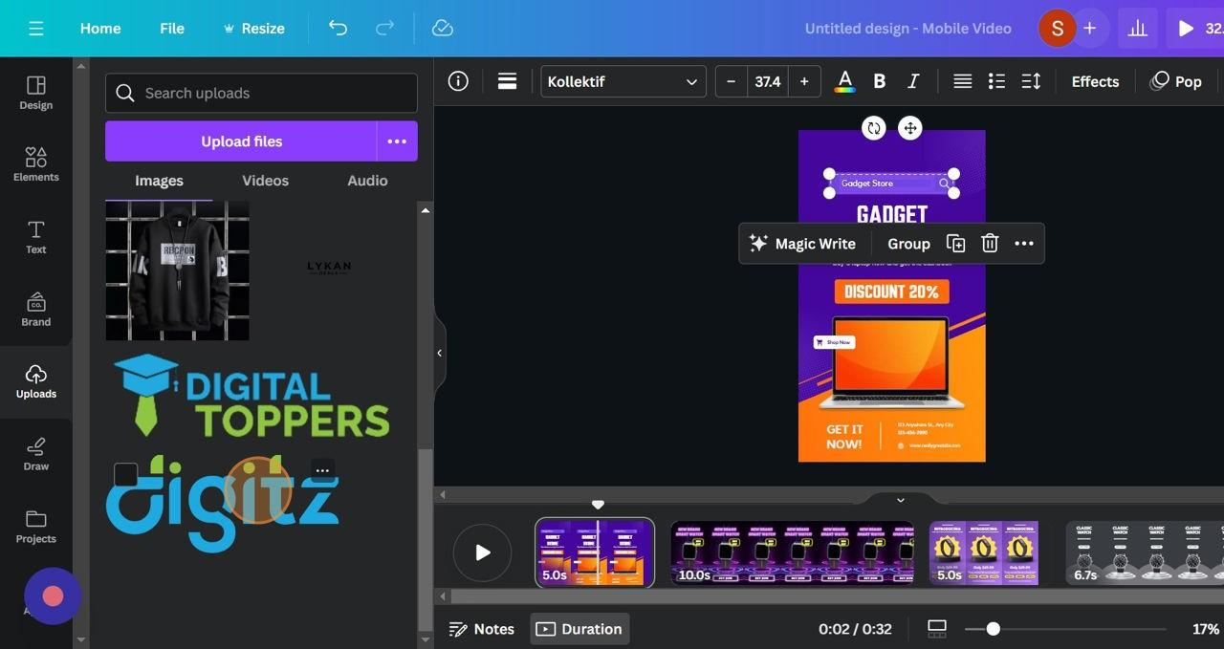

### **STEP7:** Edit Background

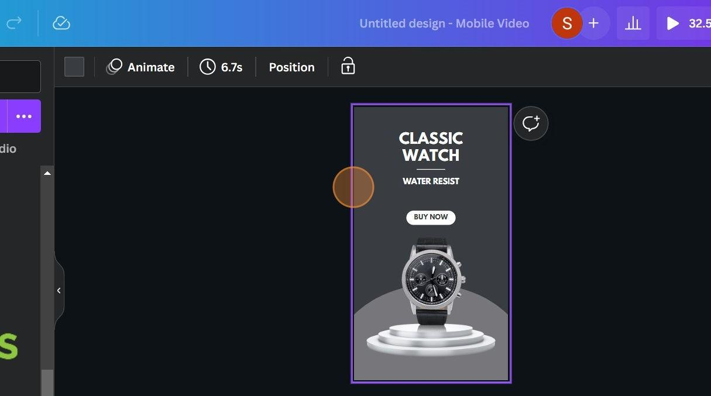

### **STEP7:** Animations

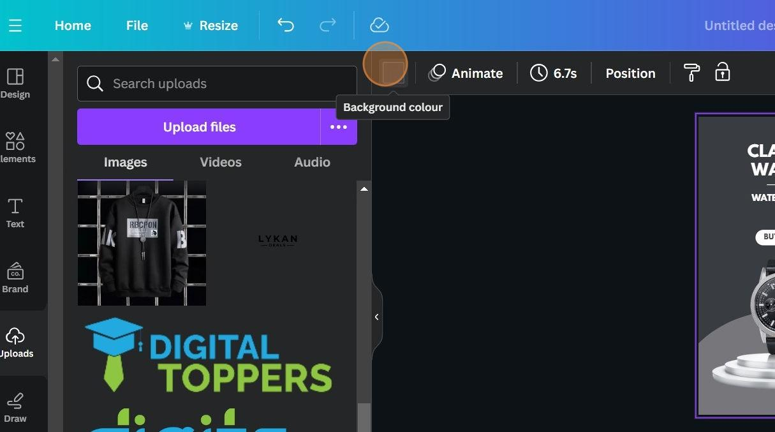

### **STEP8:** Transitions

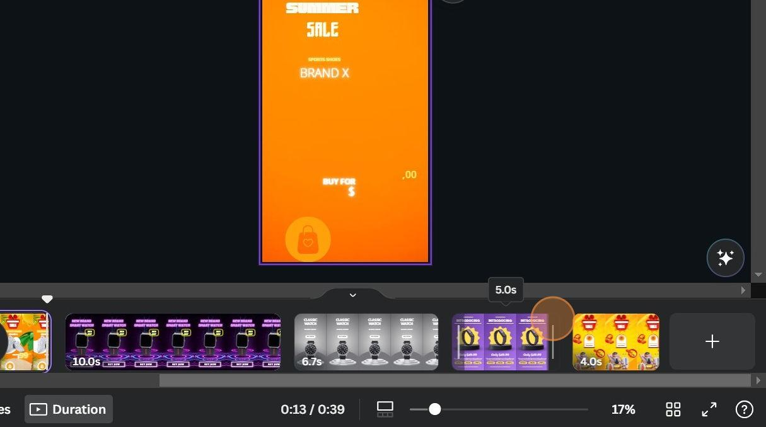

### **STEP9:** Text Effects

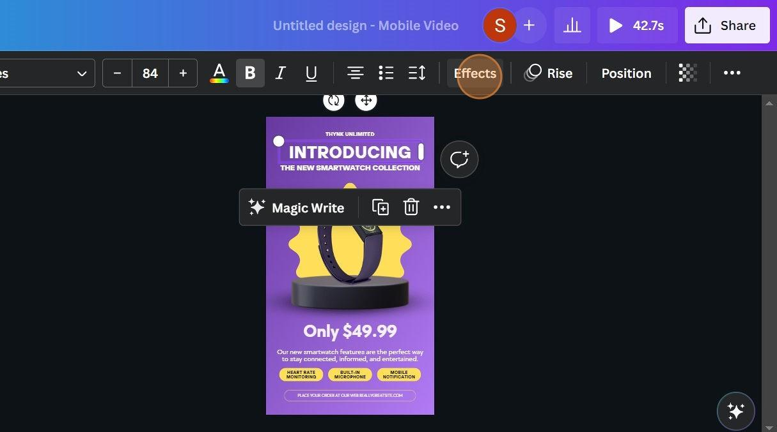

### **STEP10:** Finalise Edit

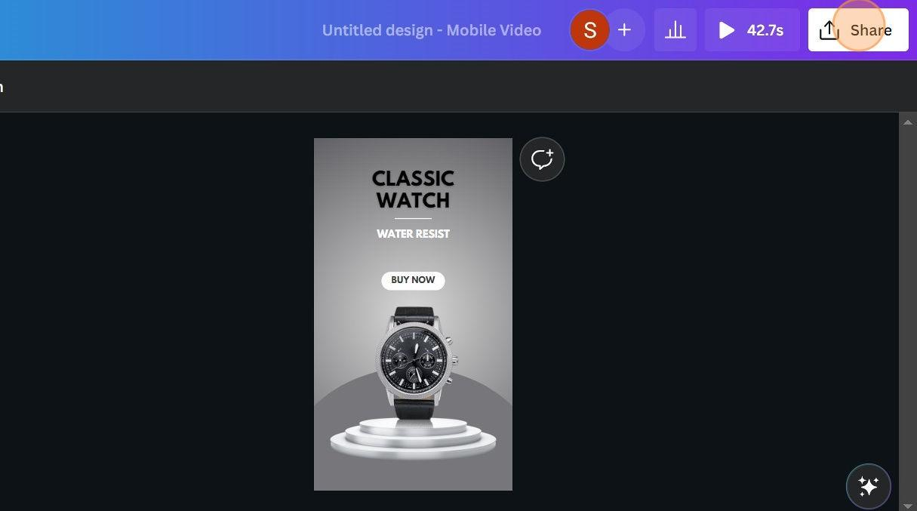

### **STEP11:** Share And Download

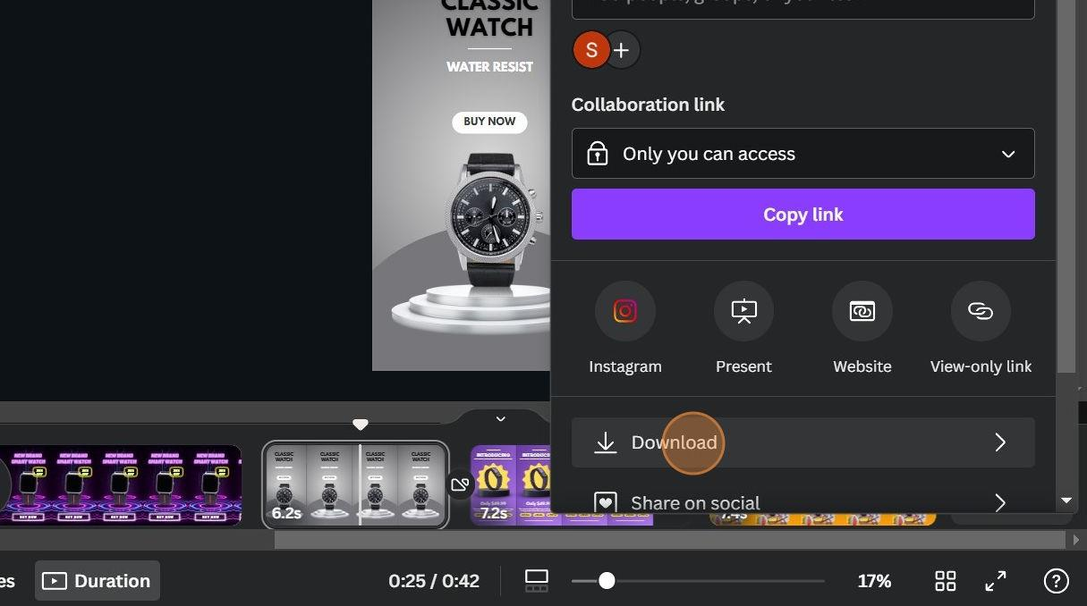

**DEMO VIDEO LINK:**[https://drive.google.com/file/d/1NsTstB3khsHUMYsiOw5KfzVVxxjoWJp/view?usp=drivesdk](https://drive.google.com/file/d/1NsTstB3-khsHUMYsiOw5KfzVVxxjoWJp/view?usp=drivesdk)